Microsoft Dynamics 365 Server hardware requirements
The following table lists the minimum and recommended hardware requirements for this version of Microsoft Dynamics 365 Server running in a Full Server configuration. These requirements assume that additional components such as Microsoft SQL Server, Microsoft SQL Server Reporting Services, Microsoft SharePoint, or Microsoft Exchange Server aren’t installed or running on the system.
Component | *Minimum | *Recommended
Processor | x64 architecture or compatible dual-core 1.5 GHz processor | Quad-core x64 architecture 2 GHz CPU or higher such as AMD Opteron or Intel Xeon systems
Memory | 4-GB RAM | 8-GB RAM or more
Hard disk | 10 GB of available hard disk space | 40 GB or more of available hard disk space

Microsoft Dynamics 365 system requirements and required technologies

- Microsoft Windows Server
- A Microsoft Windows Server Active Directory infrastructure
- An Internet Information Services (IIS) website
- Claims-based security token service (required for Internet-facing deployments)
- Microsoft SQL Server
- Microsoft SQL Server Reporting Services
- Microsoft Exchange Server or access to a POP3-compliant email server (required for email tracking)
- SharePoint Server (required for document management)
- Supported device, Microsoft Dynamics 365 app, or web browser, such as later versions of Internet Explorer or the latest versions of Apple Safari, Google Chrome and Mozilla Firefox
- Microsoft Office for Microsoft Dynamics 365 for Outlook and other Office integration features
- Email router
- Microsoft Dynamics CRM reporting authoring extension.
Microsoft Dynamics 365 reporting requirements
Microsoft Dynamics 365 Reporting Extensions are data processing extensions that are installed on the Microsoft SQL Server Reporting Services server. The Microsoft Dynamics 365 Reporting Extensions accept authentication information from Microsoft Dynamics 365 Server and pass it to the Microsoft SQL Server Reporting Services server.
Microsoft Dynamics CRM Reporting Extensions Setup includes two data processing extensions: Fetch data processing extension and SQL data processing extension. By default, these extensions are installed during Microsoft Dynamics CRM Reporting Extensions Setup:
- The Fetch data processing extension is required to create, run, and schedule Fetch-based reports.
- The SQL data processing extension is required to create, run, and schedule the default (out-of-the-box) or SQL-based custom reports inMicrosoft Dynamics 365.

SQL Server Reporting Services

Microsoft SQL Server Reporting Services is required for reporting features in Microsoft Dynamics 365.
You can use the following Microsoft SQL Server editions for Microsoft Dynamics 365 reporting;
Microsoft SQL Server 2016,
SQL Server 2014
Microsoft SQL Server 2012,

Report Authoring Extension requirements

Microsoft Dynamics 365 Report Authoring Extension is required to author Fetch-based reports used with Microsoft Dynamics 365 by using SQL Server Data Tools.
You must install the Microsoft Dynamics 365 Report Authoring Extension on a PC that has the following software.
- Microsoft Visual Studio 2015, Microsoft Visual Studio 2013, Microsoft Visual Studio 2012, or Microsoft Visual Studio 2010

Supported Windows Server 2016 editions
The following editions of the Windows Server 2016 operating system are supported for installing and running Microsoft Dynamics 365 Server:
- Windows Server 2016 Standard
- Windows Server 2016 Datacenter

Supported Windows Server 2012 editions
The following editions of the Windows Server 2012 operating system are supported for installing and running Microsoft Dynamics 365 Server:
- Windows Server 2012 R2 Standard
- Windows Server 2012 R2 Datacenter
- Windows Server 2012 Standard
- Windows Server 2012 Datacenter

Internet Information Services (IIS)
This version of Microsoft Dynamics 365 Server supports Internet Information Services (IIS) versions 8.0 and 8.5.
Internet Information Services (IIS, formerly Internet Information Server) is an extensible web server created by Microsoft for use with the Windows NT family.^{[2]} IIS supports HTTP, HTTPS, FTP, FTPS, SMTP

SQL Server editions
Any one of the following Microsoft SQL Server editions is required and must be installed on Windows Server 2008 (SP2 or R2) 64-bit-based versions or Windows Server 2012 (RTM or R2) 64-bit-based computers, running, and available for Microsoft Dynamics 365:
- *Microsoft SQL Server 2016, Enterprise with Cumulative Update 2 (CU2)
- *Microsoft SQL Server 2016, Standard with Cumulative Update 2 (CU2)
- *Microsoft SQL Server 2016, Developer, with Cumulative Update 2 (CU2) (for non-production use only)
- SQL Server 2014 Enterprise, 64-bit with SP2
- SQL Server 2014 Business Intelligence, 64-bit with SP2
- SQL Server 2014 Standard, 64-bit with SP2
- SQL Server 2014 Developer, 64-bit with SP2 (for non-production use only)
- Microsoft SQL Server 2012, Enterprise, 64-bit SP3
- Microsoft SQL Server 2012, Business Intelligence, 64-bit SP3
- Microsoft SQL Server 2012, Standard, 64-bit SP3
- Microsoft SQL Server 2012, Developer, 64-bit SP3 (for non-production use only)

Authentication Vs Authorization
Authentication and Authorization are two key security related concepts that are independent but normally go together.
Authentication is a process that verifies the identity of a user. On the hand, Authorization is the process of assigning rights/privileges to an already authenticated user.
For example, when a user tries to login a web application. The user identity is first verified that he/she is a valid registered user of the application. If his/her identity is validated successfully then the appropriate privileges are assigned accordingly. Different users may have different privileges on the same application. For example, user1 can only view/read some records while user2 may have privileges for all CRUD (Create, Read, Update and Delete) operations on the same data.

Internet Explorer and Microsoft Edge

The following table describes the Windows and Internet Explorer or Microsoft Edge versions supported for use with the Microsoft Dynamics CRM web application.
Windows version | Internet Explorer 10 | Internet Explorer 11 | Microsoft Edge
Windows 10 | Not supported1 | Supported | Supported
Windows 8.1 | Not supported1 | Supported | Not supported
Windows 8 | Supported | Not supported1 | Not supported
Windows 7 | Supported | Supported | Not supported

IIS versions and OS:
IIS Versions | OS
IIS 6.0 | Windows Server 2003, Windows XP Professional x64 Edition,
IIS 7.0 | Windows Vista and Windows Server 2008
IIS 7.5 | Windows 7 , Windows Server 2008 R2.
IIS 8.0 | Windows Server 2012 and Windows 8.
IIS 8.5 | Windows Server 2012 R2 and Windows 8.1.
IIS 10 | Windows Server 2016 and Windows 10.

Verify prerequisites

Before you install Microsoft Dynamics 365 Server, you should understand the following:
- Microsoft SQL Server can be, but is not required to be, installed on the same computer as Microsoft Dynamics 365 Server.
- If Microsoft Dynamics 365 Server and Microsoft SQL Server are installed on different computers, both computers must be in the same Active Directory service domain.
- The SQL Server service must be started and can be configured to automatically start when the computer is started.
- The Microsoft SQL Server Reporting Services service must be started and configured to automatically start when the computer is started.
- The SQL Server Agent service must be started. This service can be configured to automatically start when the computer is started.
Active Directory:
- Active Directory (AD) is a directory service that Microsoft developed for Windows domain networks. It is included in most Windows Server operating systems as a set of processes and services.
- It authenticates and authorizes all users and computers in a Windows domain type network—assigning and enforcing security policies for all computers and installing or updating software. For example, when a user logs into a computer that is part of a Windows domain, Active Directory checks the submitted password and determines whether the user is a system administrator or normal user.^{[4]} Also, it allows management and storage of information, provides authentication and authorization mechanisms, and establishes a framework to deploy other related services: Certificate Services, Federated Services, Lightweight Directory Services and Rights Management Services.
- Active Directory Domain Services (AD DS) is a feature of the Windows Server operating systems. AD DS provides a directory and security structure for network applications such as Microsoft Dynamics 365.
- As with most applications that rely on a directory service, Microsoft Dynamics 365 has dependencies that are important for operation, such as use of AD DS to store user and group information and to create application security.
- Microsoft Dynamics 365 Server should only be installed on a Windows Server that is a domain member. The domain where the server is located must be running in one of the Active Directory domain functional levels listed in the Active Directory modes

Active Directory and network requirements for Microsoft Dynamics 365:
Active Directory Domain Services (AD DS) is a feature of the Windows Server operating systems. AD DS provides a directory and security structure for network applications such as Microsoft Dynamics 365.
As with most applications that rely on a directory service, Microsoft Dynamics 365 has dependencies that are important for operation, such as use of AD DS to store user and group information and to create application security.

What kind of service account should we choose?
- Domain user account
- Network Service account.

Microsoft Dynamics CRM Server 2016 Setup

The user account used to run Microsoft Dynamics CRM Server 2016 Setup that includes the creation of databases requires the following minimum permissions:
- Be a member of the Active Directory Domain Users group. By default, Active Directory Users and Computers adds new users to the Domain Users group.
- Be a member of the Administrators group on the local computer where Setup is running.
- Have Local Program Files folder read and write permission.
- Be a member of the Administrators group on the local computer where the instance of SQL Server is located that will be used to store the Microsoft Dynamics 365 databases.
- Have sysadmin membership on the instance of SQL Server that will be used to store the Microsoft Dynamics 365 databases.
- Have organizational unit and security group creation and add membership permission to those groups in Active Directory

Microsoft Dynamics CRM installation files

The following table lists the Microsoft Dynamics CRM 2016 installation files to use and their location.
Setup file | Location
SetupServer.exe for installing Microsoft Dynamics CRM Server | ..\Server\amd64
SetupSrsDataConnector.exe for installing Microsoft Dynamics CRM Reporting Extensions | ..\Server\amd64\SrsDataConnector
SetupBIDSExtensions.exe for installing the Report Authoring Extension. This is an optional feature that can be installed on a computer that has Microsoft Visual Studio for creating and customizing fetch-based reports | ..\BIDSExtensions\i386
Setupclient.exe for installing Microsoft Dynamics CRM 2016 for Outlook | - ..\Client\amd64 for 64-bit  - ..\Client\i386 for 32-bit
SetupEmailRouter.exe for Microsoft Dynamics CRM Email Router | - ..\EmailRouter\amd64 for 64-bit  - ..\EmailRouter\i386 for 32-bit

Pre-Requisites Microsoft Dynamics CRM 2016 and Dynamics 365:
- Microsoft Dynamics CRM 2016 needs IIS server roles and Active Directory Web Services. So you need Windows Server 2012 R2 on your system.
- Also get SQL Server 2014 installed on your system.
- Now create Active Directory accounts for the CRM Sandbox Processing Service and CRM VSS Writer Service.
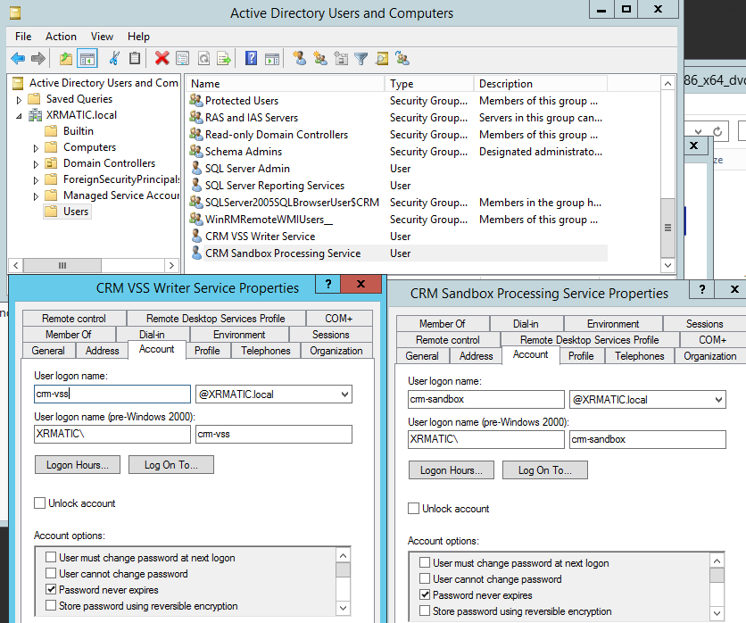

Microsoft Dynamics 365 Installation
- Ensure that you have Microsoft .NET Framework 4.5.2 installed. If not, get it installed and reboot the server.
- Now you need to run splash.exe in CRM directory and proceed with the option of: Install Microsoft Dynamics CRM Server

Dynamics CRM Installation D
1. Download the Dynamics CRM Server setup files from here

2. Run Microsoft Dynamics CRM Server Setup by navigating to the directory. It is recommended to do it with 'Run as Administrator'
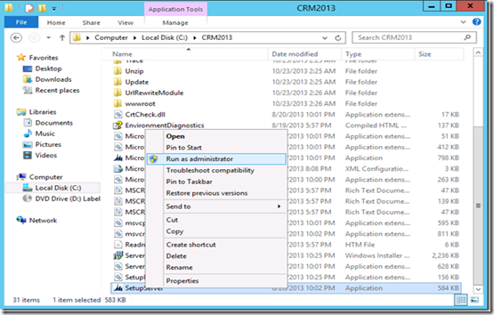

3. Welcome to Microsoft Dynamics CRM Server 2013 Setup page
On this page, we recommend that you click Get updates for Microsoft Dynamics CRM, to make sure that Setup has the most recent installation files. Click Next.

4. If there is no update needed you can proceed with the setup by clicking Next.
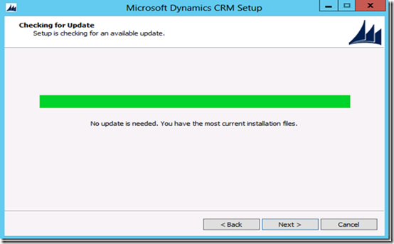
5. Product Key Information
The next step is to enter the product key. You may insert a valid commercial product key or use one of the following 90-day trial keys.

Microsoft Dynamics CRM Workgroup Server 2013 (5 CAL limit):
NX77Y-BTBCV-JP3T3-8W7JH-94QJP
Microsoft Dynamics CRM Server 2013 (no CAL limit):
CQWW3-TNXBF-HRQWC-CVTW9-M968H

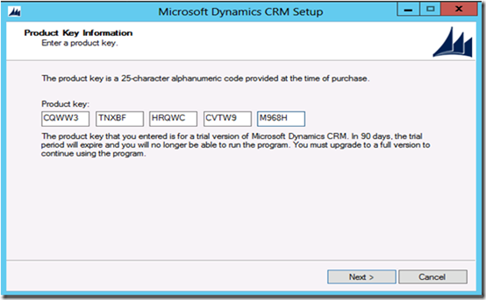
6. License Agreement page
On the License Agreement page, review the information and, if you accept the license agreement, click I accept this license agreement, and then click I Accept.

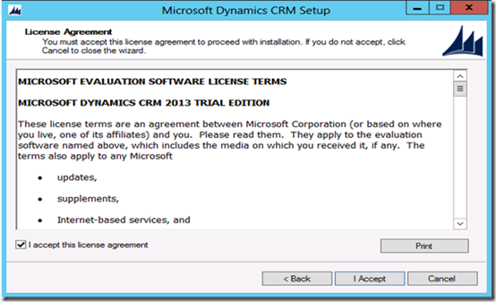
7. Install Required Components
If Setup detects that components are missing, the Install Required Components page appears.
· If you have already installed the required components, this page will not appear.
· If you have not installed the required components listed, you can install them now. Click Install. When the components are installed, the status column will change from Not Installed to Installed, and you can click Next to continue.
Note: If you are prompted to restart the computer, do so, and then start Setup again.

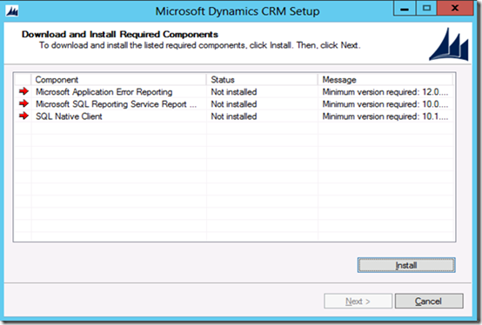

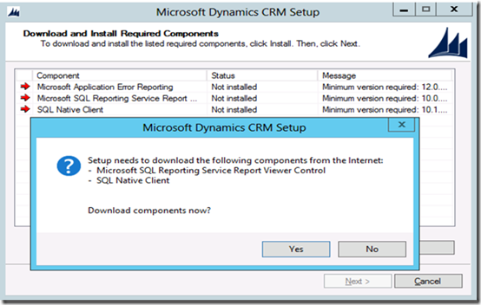
Once successfully installing all the required components, press Next to continue with the setup
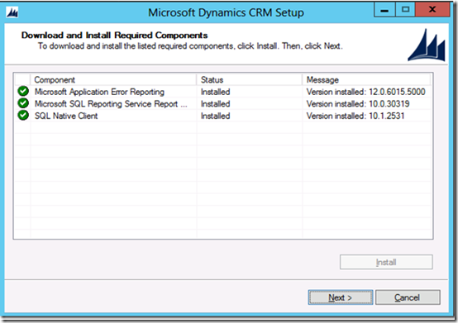
8. Select Installation Location
On the Select Installation Location page, accept the default location or enter a different file installation location, and then click Next
- Choose the location of the Install, and click Next.
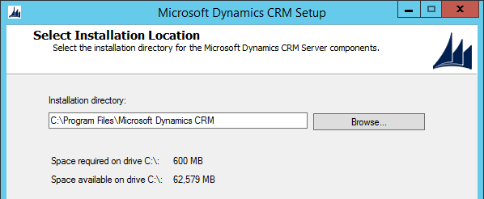
- Specify Server Roles that you wish to add or remove using the checkbox list.
- Also specify the deployment environment – create new or upgrade existing.
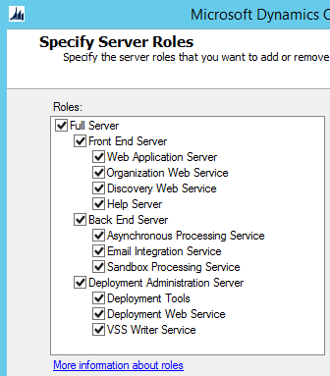
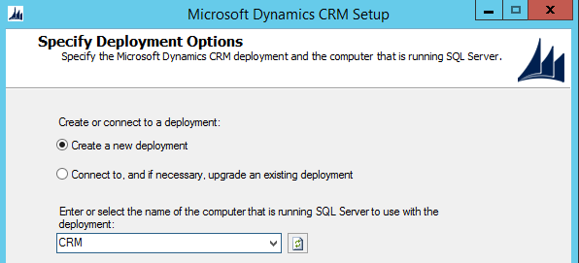
- Browse and choose the Active Directory Organizational Unit in which you wish to add the system groups.
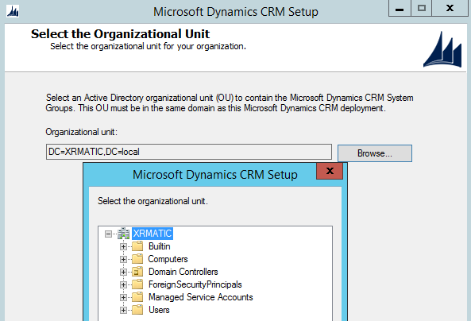
- For Specify Service Accounts window, choose NT AUTHORITY\NETWORK SERVICE for all Services except for VSS Writer Service and Sandbox Processing Service.
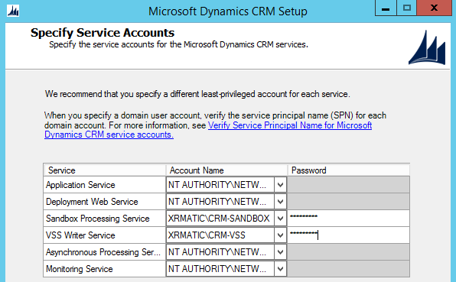
- Choose the IIS Website for web components on which you wish to install the CRM 2016.
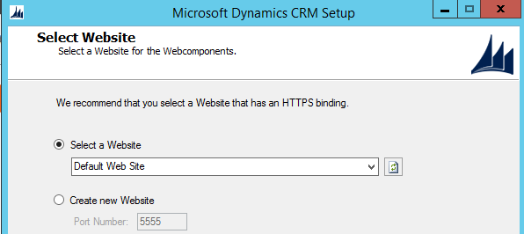
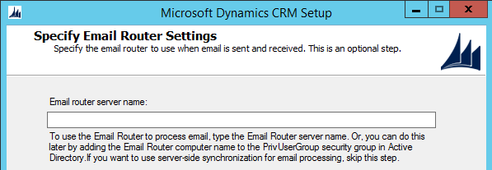
- Specify your Organization Settings. Choose a Display name
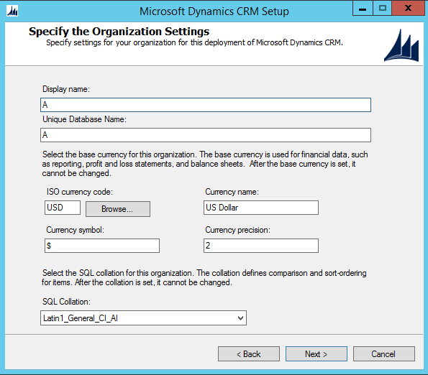
- At the System Checks page, review the verification tasks and correct any errors in order to continue.
http://win-qctbmlihah0:5555/VFSTest/main.aspx?
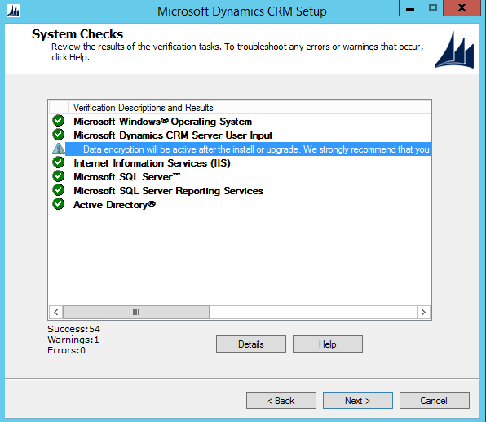
- When ready, click on Install Microsoft Dynamics CRM
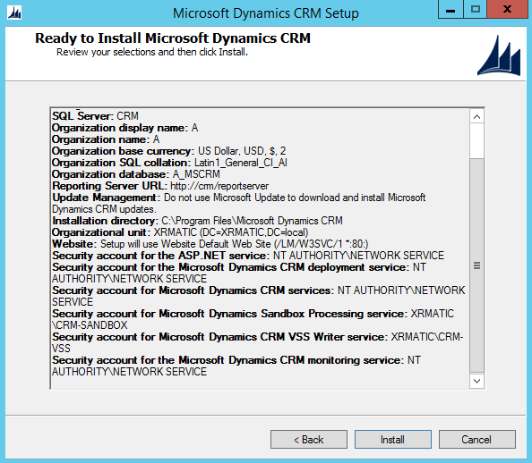
- When the installation process completes, restart the server.
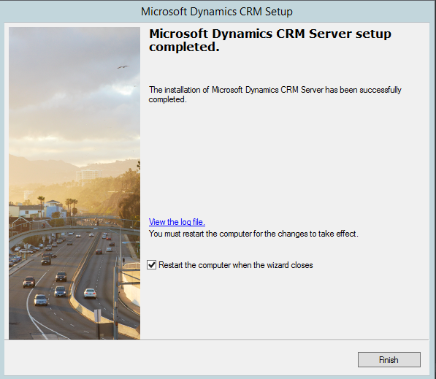
You have successfully installed Microsoft Dynamics CRM on your system.

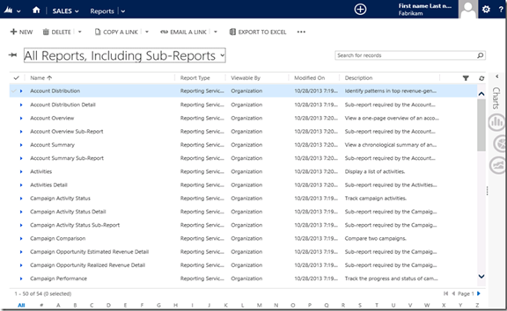

Available individual server roles

Server Role | Description | Server Group
Discovery Web Service | Finds the organization that a user belongs to in a multi-tenant deployment. | Front End Server
Organization Web Service | Supports running applications that use the methods described in the Microsoft Dynamics 365 SDK. | Front End Server
Web Application Server | Runs the Web Application Server that is used to connect users to Microsoft Dynamics 365 data. The Web Application Server role requires the Organization Web Service role. | Front End Server
Microsoft Dynamics 365 Asynchronous Processing Service | Processes queued asynchronous events, such as workflows, bulk e-mail, or data import.  Microsoft Dynamics CRM Asynchronous Processing Service and Microsoft Dynamics CRM Asynchronous Processing Service (maintenance) services (Working: Handles the processing of queued Asynchronous Events) | Back End Server
Microsoft Dynamics 365 Asynchronous Processing Service (maintenance) | Services asynchronous maintenance such as encryption key generation for authentication and database deletion clean up. | IMP
Sandbox Processing Service | Microsoft Dynamics CRM Sandbox Processing Service (Working: Handles the processing of isolated plugins) | Back End Server
Email Integration Service | Handles sending and receiving of email messages by connecting to an external email server. | Back End Server
Microsoft Dynamics 365 Monitoring Service | The service is used to detect expired digital certificates that may affect Microsoft Dynamics 365 services that are running in the deployment.
Deployment Web Service | Publishes the web service that provides the deployment interface described in the Microsoft Dynamics CRM SDK, such as those used to create an organization or manage the list of Deployment Administrators for the Microsoft Dynamics 365 deployment. | Deployment Administration Server
Microsoft Dynamics 365 VSS Writer | The Microsoft Dynamics 365 VSS Writer service provides an interface to backup and restore Dynamics 365 data | Deployment Administration Server
Microsoft Dynamics 365 Reporting Extensions | Provides reporting functionality by interfacing with the Microsoft Dynamics 365 system and Microsoft SQL Server Reporting Services. | N/A
SQL Server | Installs the MSCRM_CONFIG database on the SQL Server. | N/A

